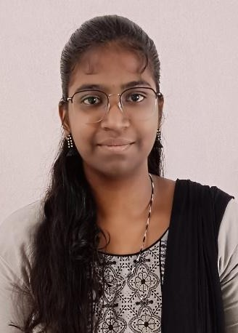
VARSITHA.A
Computer science Engineer 8610091674
varsithaa23cse@srishakthi.ac.in
 Varsitha Arun
 14/27 Patchayi Amman kovil lane,North Street,Thuraiyur.
Tiruchirappalli-621010.

ACADEMIC BACKGROUND
BE-Computer science & Engineering
Percentage : -
Year of passing : -
HSC –Central Board
Percentage :93 %
Year of passing :2023

SSLC -CBSE
Percentage : -
Year of passing : 2021

KEY STRENGTHS
- Excellent verbal and written communication skills.
- Highly organized and punctual.
- Ability to work independently as well as group.

AREA OF INTEREST
Full Stack Development

SKILLS
•MERN STACK
- JavaScript
- Node.js
- React.js
- Express.js
- Mongodb
•HTML AND CSS
•JAVA

CERTIFICATIONS:
•APP INNOVATION TECHNOLOGIES (DURATION-15 DAYS)
I have went on an internship in MERN STACK to App Innovation Technologies
•UNITED HACKS V5-HACK UNITED (JULY 11-13th)
Certification in an hackathon organized by HACK UNITED.
•MHTECHIN INNOVATION CHALLENGE-2025
I have participated in idea pitch deck submission organized by MHTECHIN.

CORE SKILLS:
- Strong in coding & algorithms.
- Skilled in web dev & databases.

IT SKILLS:
Languages : C,Java Software : MS Office

PROJECT:
TITLE: A HANDLOOM ECOMMERCE WEBSITE
DESCRIPTION:This E-commerce website aims at reaching out to the people
throughout the nation through our unique handloom products.
TECH STACK:
- JavaScript
- Node.js
- React.js
- Express.js
- HTML and CSS
- Mongodb

ACHIEVEMENTS:

•APP INNOVATION TECHNOLOGIES INTERNSHIP (MERN STACK)
•MHTECHIN HACKATHON ORGANIZED BY MHTECH
•BUILD FOLIO ORGANIZED BY MANIPUR UNIVERSITY, JAIPUR(PORTFOLIO)

INTERNSHIP:

APP INNOVATION TECHNOLOGIES (JUNE 2025-JULY 2025)
- MERN STACK WEB DEVELOPMENT

LINKS:

LINKEDIN - https://www.linkedin.com/in/varsitha-arun-8b269a284/
GITHUB - https://github.com/Varsitha-A

